**MINISTRY OF EDUCATION AND TRAINING**

**FPT UNIVERSITY**

Capstone Project Document

Design and implement smart door lock system

Report 4

|  |  |
| --- | --- |
| **Group 1** | |
| **Group member** | Bui Tran Minh Thanh – Team Leader – 60329  Nguyen Tu Duy – Team Member – 60500  Tran Quoc Thai – Team Member - 60364  Dinh Tuan Anh – Team Member - 60460 |
| **Supervisor** | Mr. Nguyen Trong Phuc |
| **Ext. Supervisor** | N/A |
| **Capstone Project code** | SLS |

-Ho Chi Minh City, 05/2014-

# Report No.4 System Design Description

## Design Overview

This session provides the designation view of SLS. It includes both technical and user interface design. System Design Description is the standard for the implement process of SLS. All the design of architecture, database, interface, common functions and business functions will be described in this session.

* The system architectural design will describes the structure of SLS. The overall view about system components and their roles will be defined here.
* The detail design section will provide a detail view of this system. It includes class diagrams, class descriptions and sequence diagrams of core functions of hardware and web. These will be the base for developer to implement our system.
* The database design will describe relationships between entities and their constraints. The detail of data type, relationship type of all tables will be declared here.
* The user interface design provides the image of system screen detail

**4.2 System Architecture Design**

**4.2.1 Architecture**

**4.2.1.1 Overview**

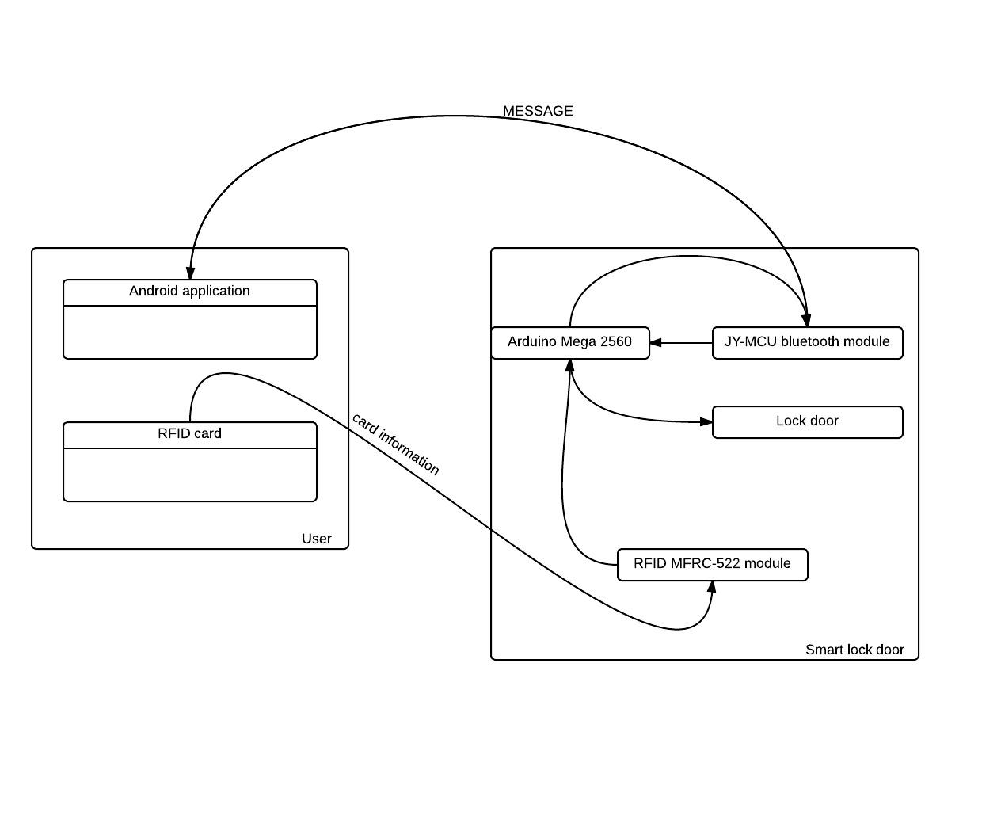

4.2.1.2 Smart lock door system

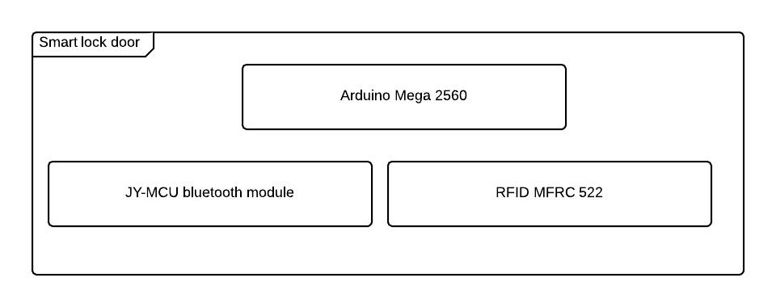

4.2.1.3 Smart lock door control

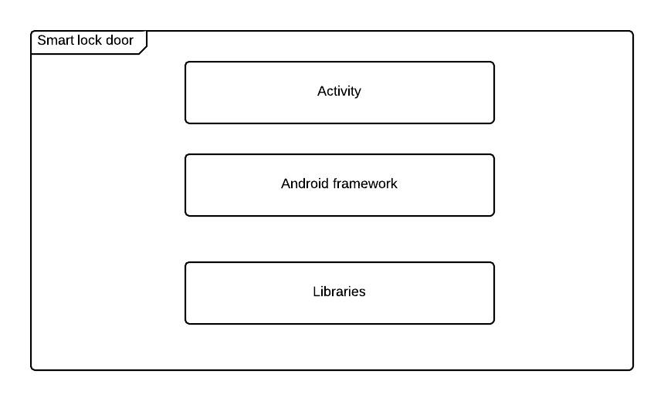

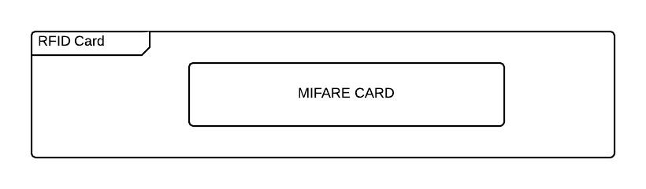

**4.2.1.4 Component Diagram**

**4.4 Detailed Design of Components**

**4.4.1 Hardware**

**4.4.1.1 Mainboard**

The Arduino mega 2560 is designed around the Atmega2560-16AU microcontroller in a 100-pin LQFP package.

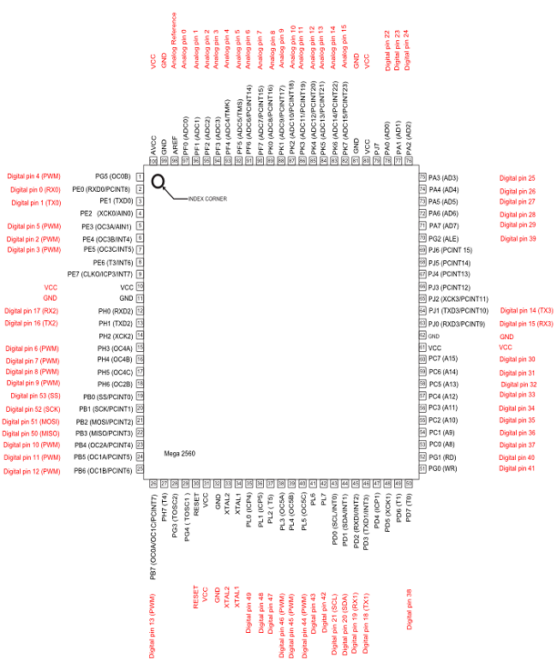

Block diagram

**Atmega2560-16AU microcontroller:**

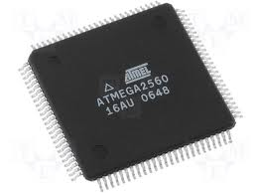

The high-performance, low-power Atmel 8-bit AVR RISC-based microcontroller combines 256KB ISP flash memory, 8KB SRAM, 4KB EEPROM, 86 general purpose I/O lines, 32 general purpose working registers, real time counter, six flexible timer/counters with compare modes, PWM, 4 USARTs, byte oriented 2-wire serial interface, 16-channel 10-bit A/D converter, and a JTAG interface for on-chip debugging. The device achieves a throughput of 16 MIPS at 16 MHz and operates between 4.5-5.5 volts.

By executing powerful instructions in a single clock cycle, the device achieves a throughput approaching 1 MIPS per MHz, balancing power consumption and processing speed.

**Power supply and power selection:**

The power supply is provided either by the host PC through the USB cable, or by an external 5V power supply.

● 5V and 3.3V can be used as output power supplies.

In this case, the 5V and 3.3V pins deliver a 5V or 3.3V power supply and power

consumption must be lower than 100 mA.

● 5V can also be used as input power supplies e.g. when the USB connector is not

connected to the PC.

**Schematic**

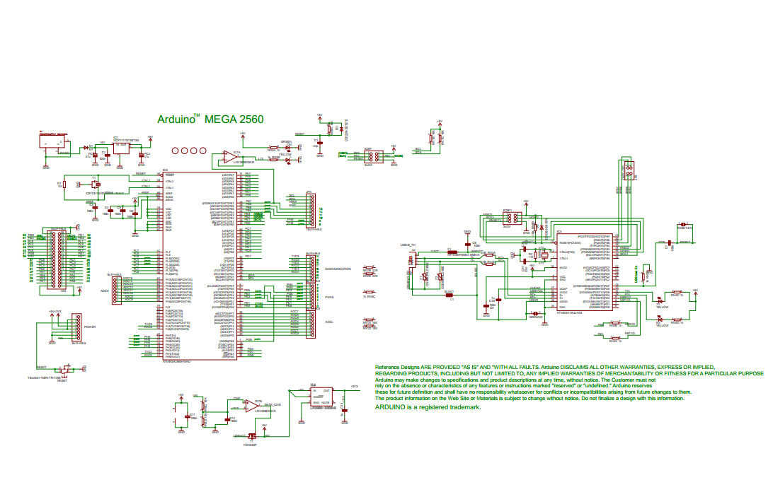

**JY-MCU bluetooth module**

The SIM908 is mounted on the board by a male connector of 20 pins, (two rows of 10 pins each) step 2 mm.

The active contacts of the connectors are:

* the power supply, VCC on pins 17 and 19;
* the power on control line (ON/OFF);
* the serial communication lines to and from the GSM module (TXD and RXD);
* the ground (GND) on pins 18 and 20;
* the Ring Indicator.

Circuit Diagram

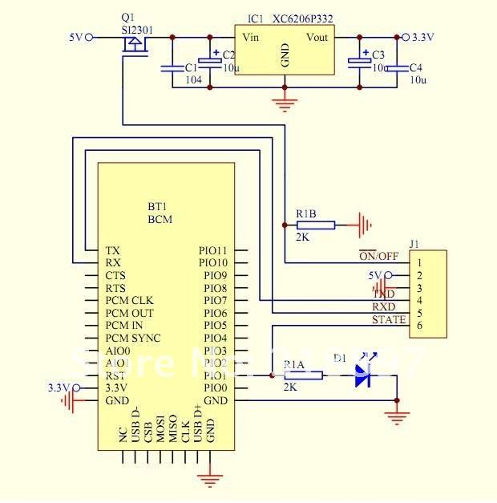

4.4.1.2 Microcontroller

**4.4.2 Software**

**Class Diagram**

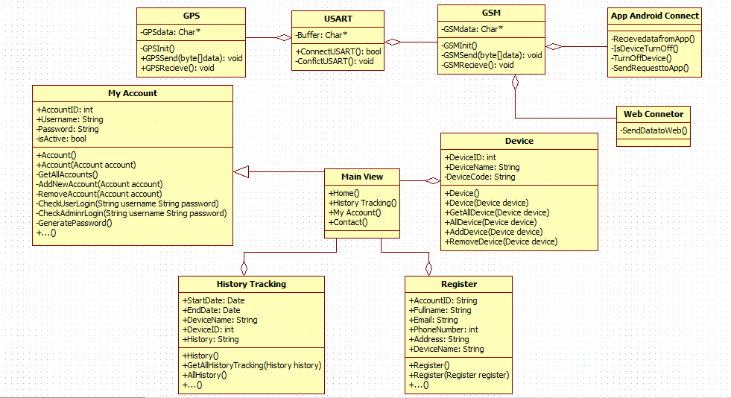

**Figure: Class Diagram**

4.4.2.1 Class Diagram Explanation

4.4.2.2

**My Account**

Attribute

|  |  |  |  |
| --- | --- | --- | --- |
| **Attribute** | **Type** | **Visibility** | **Description** |
| AccountID | Int | Public | Unique ID of each account |
| RoleID | Int | Public | Role of account |
| Username | String | Public | Username of account as an email address |
| Password | String | Private | Password of account |
| IsActive | Boolean | Private | Active status of account |

Method

|  |  |  |  |
| --- | --- | --- | --- |
| **Method** | **Return Type** | **Visibility** | **Description** |
| GetAllAccounts | List<Account> | Private | Get all accounts in system |
| CheckUserLogin | Boolean | Private | Check if username and password is correct or not to log in to the system (User use system) |
| CheckAdminLogin | Boolean | Private | Check if username and password is correct or not to log in to the system (Role Admin) |
| GeneratePassword | String | Private | Auto generate a 6 letters length password |
| DeactivateAccount | Boolean | Private | Deactivate an account |
| ActivateAccount | Boolean | Private | Activate an account |
| GetSingleAccount | Account | Private | Get a single account from system using its username |
| GetAccountByID | Account | Private | Get a single account from system using its ID |
| AddNewAccount | Account | Private | Add new account to system(Role Admin) |
| RemoveAccount | Account | Private | Remove new account to system(Role Admin) |

4.4.2.3

History Tracking

**Attribute**

|  |  |  |  |
| --- | --- | --- | --- |
| **Attribute** | **Type** | **Visibility** | **Description** |
| StartDateTime | DateTime | Public | DateTime begins Tracking |
| EndDateTime | DateTime | Public | DateTime ends Tracking |
| DeviceName | String | Public | Name of device |
| DeviceID | String | Public | ID of device |

**Method**

|  |  |  |  |
| --- | --- | --- | --- |
| **Method** | **Return Type** | **Visibility** | **Description** |
| GetAllHistoryTracking | List<history> | Public | Get all history tracking of device in system |

**Device**

**Attribute**

|  |  |  |  |
| --- | --- | --- | --- |
| **Attribute** | **Type** | **Visibility** | **Description** |
| DeviceName | String | Public | Name of device |
| DeviceID | int | Public | Unique ID of each device |
| DeviceCode | String | Private | Code of device when add device to system |

**Method**

|  |  |  |  |
| --- | --- | --- | --- |
| **Method** | **Return Type** | **Visibility** | **Description** |
| GetAllDevice | List<device> | Public | Get all device in system |
| AddDevice | Device | Public | Add new device to each account |
| RemoveDevice | Device | Public | Remove device out of system. |

**Register**

**Attribute**

|  |  |  |  |
| --- | --- | --- | --- |
| **Attribute** | **Type** | **Visibility** | **Description** |
| AccountID | String | Public | Unique ID of each account |
| FullName | String | Public | Name of customer registration |
| Email | String | Public | Email when user registration account |
| PhoneNumber | int | Public | Number phone when used device |
| Address | String | Public | Address of user when registration account |
| DeviceName | String | Public | Unique Name of each Device |

**Method**

|  |  |  |  |
| --- | --- | --- | --- |
| **Method** | **Return Type** | **Visibility** | **Description** |

**USART**

**Attribute**

|  |  |  |  |
| --- | --- | --- | --- |
| **Attribute** | **Type** | **Visibility** | **Description** |
| Buffer | Char* | Private | USART is buffer to connect device by GPS and GSM |

**Method**

|  |  |  |  |
| --- | --- | --- | --- |
| **Method** | **Return Type** | **Visibility** | **Description** |
| Connect USART | boolean | Public | Connect to USART |
| Confict USART | Void | Private | Confict USART |

**GPS**

**Attribute**

|  |  |  |  |
| --- | --- | --- | --- |
| **Attribute** | **Type** | **Visibility** | **Description** |
| GPS data | Char* | Private | Device will send or receive data by GPS |

**Method**

|  |  |  |  |
| --- | --- | --- | --- |
| **Method** | **Return Type** | **Visibility** | **Description** |
| GPS Init | GPS | Private | GPS Init |
| GPS Send Data | Void | Public | Send data to GPS |
| GPS Receive Data | Void | Public | Receive data to GPS |

**GSM**

**Attribute**

|  |  |  |  |
| --- | --- | --- | --- |
| **Attribute** | **Type** | **Visibility** | **Description** |
| GSM data | Char* | Private | Device will send or receive data by GPS |

**Method**

|  |  |  |  |
| --- | --- | --- | --- |
| **Method** | **Return Type** | **Visibility** | **Description** |
| GSM Init | GSM | Private | GPS Init |
| GSM Send Data | Void | Public | Send data to GPS |
| GSM Receive Data | Void | Public | Receive data to GPS |

**App Android Connect**

**Attribute**

|  |  |  |  |
| --- | --- | --- | --- |
| **Attribute** | **Type** | **Visibility** | **Description** |

**Method**

|  |  |  |  |
| --- | --- | --- | --- |
| **Method** | **Return Type** | **Visibility** | **Description** |
| Receive Data From App | Void | Private | Receive data from App |
| Is Device Turn Off | Void | Private | State of device will be send to app |
| Device Turn Off | Void | Private | Turn Off device |
| Send Request To App | Void | Private | Send request to App |

**Web Connector**

**Attribute**

|  |  |  |  |
| --- | --- | --- | --- |
| **Attribute** | **Type** | **Visibility** | **Description** |

**Method**

|  |  |  |  |
| --- | --- | --- | --- |
| **Method** | **Return Type** | **Visibility** | **Description** |
| Send data to Web | Void | Private | Send data to Web |

**4.5 Sequence Diagram**

**Login**

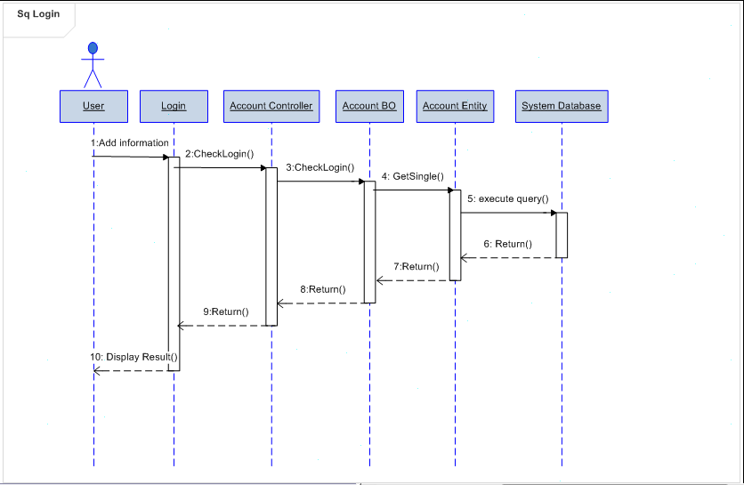

**History Tracking**

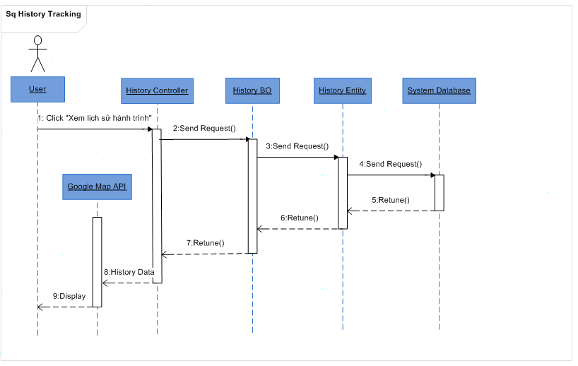

**Device**

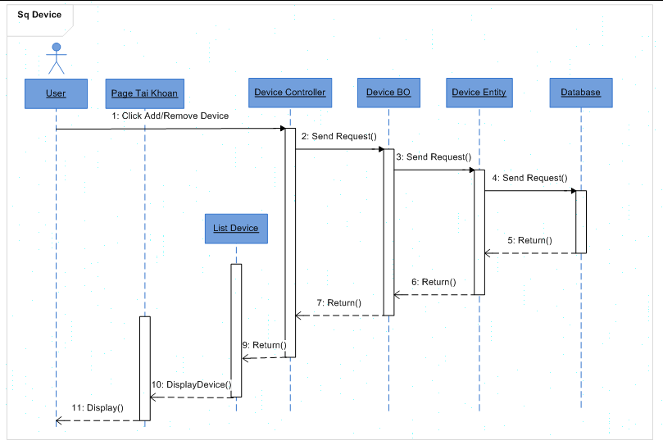

Message OFF Device

